[ AI-Driven Loan Default Prediction Using Banking Analytics]
S. Tejasree, B. Sruthi, B. Bhavya Sai Sree
Department of Computer Science and Engineering, KLH University, Bachupally, Hyderabad
Data Analytics & Visualisation – (24DSB3101) — Project Report

ABSTRACT
Loan default is a major challenge in the banking sector because increasing defaults and non-performing assets can negatively affect profitability, liquidity, and overall financial stability. Accurate prediction of loan default can help banks identify high-risk borrowers and support better credit-risk management. This paper proposes an AI-driven loan default prediction framework using explainable machine learning and banking analytics. Three public credit datasets, namely Lending Club, Statlog German Credit, and Home Credit, are considered to provide different credit-risk scenarios. The proposed approach includes data preprocessing, exploratory data analysis, risk-aware feature engineering, and comparison of five machine-learning models: Logistic Regression, Decision Tree, Random Forest, XGBoost, and CatBoost. Accuracy, Precision, Recall, F1-score, and ROC-AUC are used to evaluate model performance. To improve transparency, SHAP and LIME are incorporated to explain both overall feature importance and individual predictions. A visualization dashboard is also proposed to present model results and credit-risk insights in an understandable form. The main contribution of the work is an integrated framework that combines predictive performance, explainability, multi-dataset evaluation, and visualization for credit-risk analysis. At the current project stage, the framework represents the proposed methodology and evaluation plan, with final experimental results to be obtained after model implementation and testing.
Keywords
Loan default prediction; Credit risk; Explainable AI; Machine learning; SHAP; LIME; Banking analytics; Credit scoring; CatBoost; Risk prediction
1. INTRODUCTION
1.1 Background
Loan default is a major challenge in the banking and financial sector because increasing defaults and non-performing assets (NPAs) can negatively affect profitability, liquidity, and overall financial stability. Banks need reliable methods to identify borrowers who are likely to default so that appropriate credit-risk management decisions can be made. Traditional credit-scoring approaches may face difficulties when dealing with large, complex, imbalanced, and fragmented financial datasets.
Machine learning provides an opportunity to analyze borrower and credit-related information and identify patterns associated with loan default. However, predictive performance alone is not sufficient for financial applications because credit decisions should also be understandable and transparent. Explainable Artificial Intelligence (XAI) techniques such as SHAP and LIME can help explain model predictions and identify the factors influencing credit-risk decisions. Therefore, combining machine learning, explainability, banking analytics, and visualization can provide a more transparent approach to loan default prediction.
1.2 Problem Statement
Existing loan default prediction approaches often focus primarily on improving predictive performance, while challenges related to data imbalance, model transparency, and practical decision support remain. Many studies also evaluate models using a single dataset or apply explainability only after selecting the final model, making it difficult to understand how different models behave across different credit-risk scenarios.
The core research problem is to develop an explainable machine-learning framework that can predict loan defaults across multiple credit datasets while providing transparent model comparisons and understandable credit-risk insights.
1.3 Research Gap
Previous studies have demonstrated the effectiveness of machine-learning and ensemble methods for credit-risk and loan-default prediction. However, many existing approaches are validated using only a single or a limited number of datasets, which restricts the assessment of generalizability. Explainability is also frequently applied after model selection rather than being considered across candidate models. In addition, there is a trade-off between predictive performance and interpretability, while practical decision-support and visualization layers are often missing. These gaps motivate an integrated approach combining multi-dataset evaluation, systematic model comparison, explainability, and visualization.

1.4 Research Objectives
- To design an AI-driven loan default prediction framework using banking analytics, data preprocessing, exploratory data analysis, and risk-aware feature engineering.
- To evaluate and compare five machine-learning models: Logistic Regression, Decision Tree, Random Forest, XGBoost, and CatBoost.
- To validate the proposed approach across three public credit datasets: Lending Club, Statlog German Credit, and Home Credit.
- To measure model performance using Accuracy, Precision, Recall, F1-score, and ROC-AUC, along with SHAP and LIME for explainability.
- To develop a visualization dashboard that presents model performance, feature importance, and credit-risk insights in an understandable form.
1.5 Research Questions
- RQ1: How do Logistic Regression, Decision Tree, Random Forest, XGBoost, and CatBoost compare for loan default prediction across different credit datasets?
- RQ2: Which machine-learning model provides the most suitable balance between predictive performance and interpretability for credit-risk prediction?
- RQ3: How consistent are the model performances and important risk-related features across the Lending Club, Statlog German Credit, and Home Credit datasets?
- RQ4: How can explainable predictions and visualization support practical credit-risk analysis and decision-making?
- 1.6 Contributions
- An integrated loan default prediction framework combining three public credit datasets, machine learning, explainability, and banking analytics.
- A systematic benchmark of five machine-learning models using common credit-risk performance metrics.
- An evaluation approach incorporating SHAP and LIME to provide both overall feature-importance analysis and explanations for individual predictions.
- A visualization dashboard designed to present model results and credit-risk insights in an understandable and practical form.
1.7 Organization of the Paper
Section 2 reviews related work on machine learning, credit-risk prediction, and explainable AI. Section 3 details the proposed methodology, including datasets, preprocessing, feature engineering, models, and explainability techniques. Section 4 describes the experimental setup and evaluation metrics. Section 5 presents the experimental results. Section 6 discusses the findings and their implications. Section 7 describes the limitations of the study. Section 8 concludes the paper and presents future work.
2. RELATED WORK
2.1 Existing Approaches
Traditional loan and credit-risk assessment methods mainly rely on credit scores, predefined rules, and manual evaluation of borrower information. These approaches are widely used but may have limitations when handling large, complex, and imbalanced credit datasets. Machine-learning techniques have therefore been increasingly explored for identifying borrowers who are likely to default. However, high predictive performance alone is not sufficient for banking applications, where understanding the reasons behind a prediction is also important.
2.2 Machine Learning / Computational Approaches
Recent studies have evaluated ensemble and machine-learning methods for credit-risk prediction. Aruleba and Sun [1] compared ensemble classifiers using techniques such as Random Forest, AdaBoost, XGBoost, and LightGBM, together with SMOTE-ENN and SHAP. Zhu et al. [2] proposed a LightGBM-XGBoost-LocalEnsemble approach for credit-risk prediction. Cai et al. [6] compared seven machine-learning models and reported strong performance from CatBoost. Zhang [7] applied explainable machine learning to the Home Credit dataset. These studies demonstrate the potential of machine learning for improving credit-risk prediction, but several approaches focus on limited datasets or do not provide an integrated decision-support framework.
2.3 Advanced / Alternative Approaches
Advanced approaches have also been investigated to improve prediction performance and handle imbalanced credit data. Hartomo et al. [5] proposed a weighted-loss TabTransformer for imbalanced credit-risk prediction. Liang et al. [10] investigated explainable deep learning for technology-based SME credit risk. Kofidis et al. [11] studied balancing techniques across models including CNN, LSTM, Random Forest, and SVM. Although these approaches can improve predictive capability, they may introduce additional complexity and can make model interpretation more difficult.
2.4 Explainability / Interpretability (or other relevant sub-theme)
Explainability is particularly important in credit-risk applications because financial decisions require transparency and justification. SHAP can provide feature-level explanations for model predictions, while LIME can explain individual predictions locally. Several recent studies have incorporated explainable AI, but the literature indicates that explainability is often applied after selecting a final model rather than being considered throughout the model-comparison process. This creates a need for a framework that evaluates predictive performance and interpretability together.
2.5 Critical Comparison
Table 1 summarizes representative studies from the literature, highlighting their key contributions and limitations.

# | Study / Publication | Key Contribution | Limitation
1 | Aruleba & Sun, IEEE Access, 2024 [1] | Used ensemble classifiers including RF, AdaBoost, XGBoost and LightGBM with SMOTE-ENN and SHAP for credit-risk prediction. | Limited to two datasets; SHAP was applied only after model selection.
2 | Zhu et al., IEEE ICETCI, 2024 [2] | Proposed LightGBM–XGBoost–LocalEnsemble stacking for credit-default prediction. | Did not include an explainability or decision-support layer.
3 | Vihurskyi, IEEE ICDCECE, 2024 [3] | Applied XAI to credit-card fraud/default detection to improve interpretability and analyst trust. | Used a single dataset and did not benchmark XAI across candidate models.
4 | Gonaygunta et al., IEEE SIEDS, 2025 [4] | Developed interpretable credit-scoring models using XAI for financial risk assessment. | Focused on metrics and interpretability without a dashboard or decision-support layer.
5 | Hartomo, Arthur & Nataliani, IEEE Access, 2025 [5] | Proposed a weighted-loss TabTransformer with explainability for imbalanced credit-risk prediction. | Evaluated on a single dataset and involved a transparency–accuracy trade-off.
Table 1. [ Comparison of representative studies based on their key contributions and limitations.]

2.6 Research Gap (Summary)
The reviewed studies show four main gaps: limited multi-dataset validation, explainability often being applied at a later stage, a trade-off between predictive performance and interpretability, and limited practical decision-support or visualization. To address these gaps, the proposed work considers three credit datasets and compares five machine-learning models—Logistic Regression, Decision Tree, Random Forest, XGBoost, and CatBoost—while incorporating SHAP, LIME, and a visualization dashboard.
3. PROPOSED METHODOLOGY
3.1 Overall Framework
The proposed framework follows an end-to-end pipeline for explainable loan-default prediction. Three benchmark datasets—Lending Club, Statlog German Credit, and Home Credit—are first collected and prepared for analysis. The data then undergo cleaning and exploratory data analysis using more than 12 analytical techniques. Risk-aware features such as debt-to-income ratio, credit utilization, and repayment consistency are engineered before model development. Five machine-learning models are then trained and compared: Logistic Regression, Decision Tree, Random Forest, XGBoost, and CatBoost. SHAP and LIME are used for explainability, followed by a visualization dashboard that presents prediction results and their explanations. The models are evaluated using Accuracy, Precision, Recall, F1-score, and ROC-AUC.

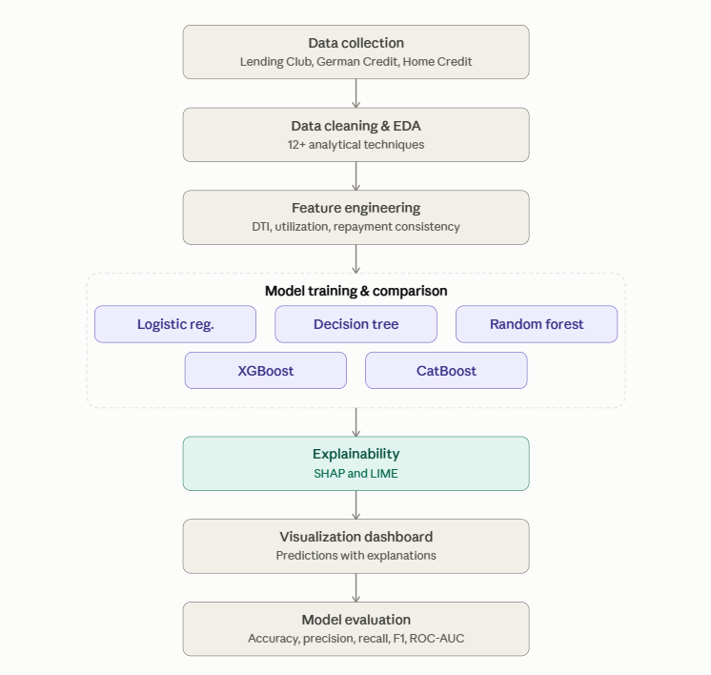
Fig. 1. Overall framework for loan-default prediction using data preprocessing, exploratory analysis, feature engineering, machine-learning models, explainability, and visualization.

3.2 Dataset(s)
• Lending Club Dataset — Source: Lending Club public loan data. Description: Contains borrower and loan-related information used to analyse consumer loan repayment and default risk. It was selected to represent a large-scale consumer lending environment.
• Statlog German Credit Dataset — Source: UCI Machine Learning Repository. Description: A standard credit-scoring dataset containing borrower financial and credit-related attributes with a credit-risk classification. It was selected as a classical benchmark for credit-risk prediction.
• Home Credit Dataset — Source: Home Credit public dataset. Description: Contains consumer-finance information used for predicting loan repayment difficulties. It was selected to evaluate the proposed models on a different credit-risk environment and to support comparison with previous Home Credit research.
The three datasets are analysed through a common preprocessing, modelling, evaluation, and explainability pipeline. The project uses multiple datasets to address the single-dataset limitation identified in previous studies.
3.3 Data Preprocessing
The three datasets are processed separately before model development because their attributes, formats, and target variables differ. The preprocessing stage is designed to produce clean and analysis-ready data while preserving the characteristics of each credit-risk dataset.
The main preprocessing steps include:
- Missing-value analysis: Missing observations are identified and handled using suitable imputation or removal strategies depending on the variable.
- Duplicate and data-quality checking: Duplicate records and inconsistent entries are examined and addressed.
- Categorical encoding: Categorical variables are converted into numerical representations suitable for machine-learning models.
- Outlier analysis: Numerical variables are examined for extreme observations and their influence on the analysis.
- Class-imbalance analysis: The distribution of default and non-default cases is examined because default cases may represent a smaller proportion of the data. SMOTE or class-weighting techniques may be considered where required.
- Feature scaling: Scaling is applied where required, particularly for models sensitive to the magnitude of input variables.
These preprocessing operations are performed before modelling so that encoding and class-imbalance decisions are based on the characteristics observed during exploratory analysis. The project specifically identifies class imbalance as an important issue in credit-risk prediction.
3.4 [ Exploratory Analysis / Feature Engineering, as relevant ]
[ Describe how you explored or engineered the data before modeling, referring to Figure 2 if useful. ]

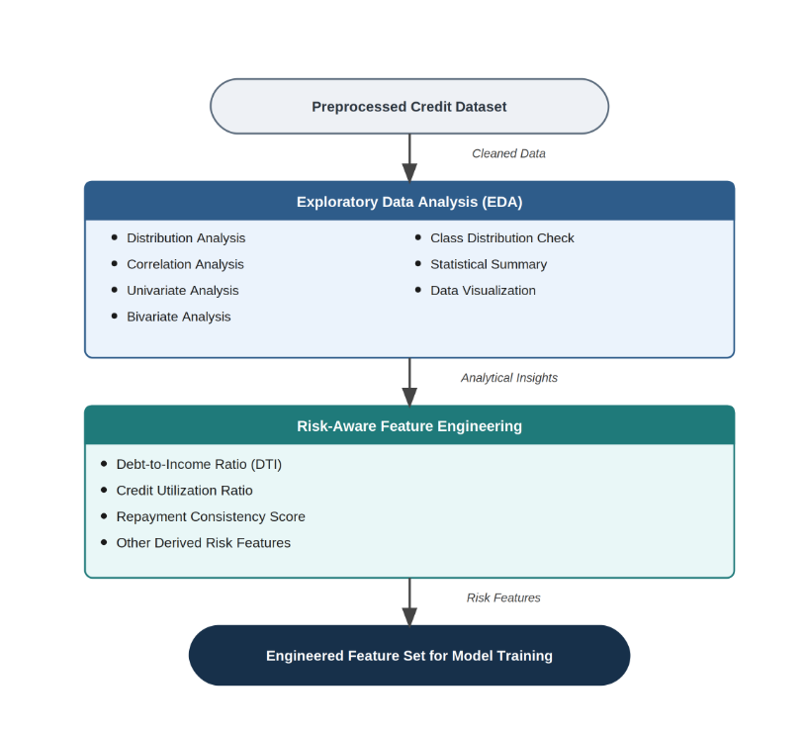
Fig. 2. EDA and risk-aware feature engineering workflow.
3.5 Proposed Model(s) and Baselines
• Logistic Regression — A simple baseline model for binary loan-default classification, included to provide an interpretable reference for comparison.
• Decision Tree — A tree-based model that produces simple decision rules and provides an interpretable benchmark.
• Random Forest — An ensemble of decision trees included to improve predictive performance and handle complex relationships in credit data.
• XGBoost — A gradient-boosting model included for its ability to capture non-linear relationships and strong predictive performance in credit-risk tasks.
• CatBoost — A boosting model included for effective handling of categorical variables and comparison with other ensemble approaches. These models support the project's simple-to-complex benchmarking strategy.

3.6 Algorithmic / Mathematical Formulation
For binary loan-default prediction, Logistic Regression estimates the probability of default as:
$$\begin{matrix} & P\left(Y=1∣X\right)=\frac{1}{1+e^{-\left(β_{0}+β_{1}X_{1}+⋯+β_{n}X_{n}\right)}} & & \text{(1)}\end{matrix}$$
where $Y$represents the default outcome, $X_{1},…,X_{n}$are the input features, and $β_{0},…,β_{n}$are the model parameters.
4. EXPERIMENTAL SETUP
4.1 Hardware and Software
The proposed implementation uses Python and open-source machine-learning and data-analysis libraries. The framework is designed to run on standard student computing hardware or free cloud-based environments. The main tools include Python, data-analysis libraries, machine-learning libraries, and visualization tools for EDA, model evaluation, SHAP, and LIME analysis.
4.2 Dataset Split / Design
Each dataset is processed separately and evaluated using a common modelling framework. A stratified train-test split is planned so that the class distribution is maintained between training and testing data. The test portion is kept separate from model training and tuning to provide an unbiased evaluation.
4.3 Hyperparameter Configuration
Model hyperparameters will be selected using model-appropriate tuning procedures on the training data. The test data will not be used for hyperparameter selection in order to avoid data leakage and maintain reliable performance evaluation.
4.4 Validation Strategy
The models will be evaluated consistently across the three datasets using the same evaluation metrics. Class imbalance will be considered during preprocessing, with techniques such as SMOTE or class-weighting considered where appropriate.
4.5 Evaluation Metrics
Accuracy — Measures the proportion of correctly classified instances; higher values indicate better overall classification accuracy.
• Precision — Measures the proportion of predicted defaults that are actually defaults; higher values indicate fewer false-positive predictions.
• Recall — Measures the proportion of actual defaults correctly identified; higher values indicate better detection of risky borrowers.
• F1-score — Harmonic mean of precision and recall; higher values indicate a better balance between the two.
4.6 Statistical Testing
At the current project stage, no specific statistical significance test has been finalized. Statistical testing may be considered after model implementation to determine whether observed differences between models are statistically meaningful.
5. RESULTS
The study is currently at the proposed methodology and evaluation stage; therefore, confirmed empirical results are not yet available. The following results structure will be populated after implementation and testing.
5.1 Overall Performance
The performance of Logistic Regression, Decision Tree, Random Forest, XGBoost, and CatBoost will be compared using Accuracy, Precision, Recall, F1-score, and ROC-AUC. The final results will identify the model providing the most suitable balance between predictive performance and interpretability across the evaluated datasets.
5.2 Model / Method Comparison
Table 2 compares the performance of each method/model considered in this study.

Method | Metric A | Metric B | Notes
Logistic Regression | To be evaluated | To be evaluated | Baseline model
Decision Tree | To be evaluated | To be evaluated | Interpretable tree-based model
Random Forest | To be evaluated | To be evaluated | Ensemble learning model
XGBoost | To be evaluated | To be evaluated | Gradient boosting model
Table 2. [ Caption summarizing this results table. ]

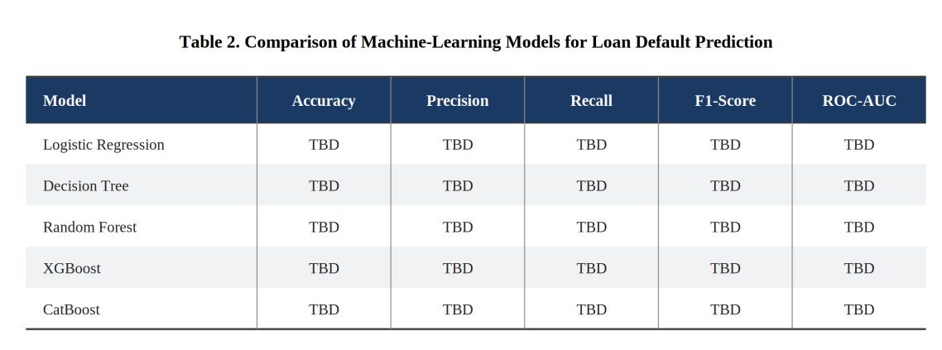
[ Figure 3 — Chart visualizing Table 2 ]
Fig. 3. [ Caption describing this chart. ]

5.3 [ Additional Result Sub-section, e.g., Error/Confusion Analysis ]
A confusion matrix will be used to analyse correct and incorrect predictions for default and non-default cases. Particular attention will be given to false negatives, as missed default cases are important in credit-risk prediction.
5.4 [ Additional Result Sub-section, e.g., Feature/Factor Importance ]
Feature importance will be analysed to identify the variables contributing most to loan-default predictions. SHAP and LIME will be used to provide global and individual-level explanations of model predictions.
6. DISCUSSION
6.1 Interpretation of Findings
The final results will be interpreted based on the performance of the five models across the three datasets. Differences between models will be examined in terms of predictive performance, feature representation, and model complexity.
6.2 Comparison With Previous Studies
The findings will be compared with the reviewed studies, particularly those using ensemble models and explainable machine learning. The comparison will examine whether the proposed multi-dataset framework and explainability approach address the limitations identified in previous work.
6.3 Theoretical Implications
The study explores how predictive performance and interpretability can be considered together in credit-risk modelling rather than relying only on accuracy-based model selection.
6.4 Practical Implications
The proposed framework can support credit-risk decision-making by combining default predictions with understandable explanations. The planned dashboard will present model outputs and risk-related insights in a form suitable for decision support.
6.5 Unexpected Findings
Any unexpected differences in model performance, feature importance, or dataset behaviour will be reported after the experimental evaluation is completed.
7. LIMITATIONS
Project-stage limitation — Final experimental results are not yet available because the implementation and evaluation are still in progress.
• Data limitation — The study uses publicly available datasets that differ in structure, variables, and credit-risk characteristics.
• Method limitation — Model performance may depend on preprocessing, feature engineering, and class-imbalance handling.
• Generalizability limitation — Results obtained from public datasets may not directly represent every real-world banking environment.
8. CONCLUSION AND FUTURE WORK
This paper proposes an AI-driven framework for loan-default prediction using banking analytics and explainable machine learning. The framework considers three credit datasets and compares five machine-learning models using multiple evaluation metrics. SHAP and LIME are incorporated to improve the interpretability of predictions, while a visualization dashboard is proposed for decision support. The overall approach combines predictive modelling, multi-dataset evaluation, explainability, and visualization.
Future work:
• Implement and evaluate the five proposed models across the three datasets.
• Complete SHAP and LIME explainability analysis.
• Develop the visualization dashboard.
• Analyse and report the final experimental results.
DECLARATIONS
Funding
No external funding was received for this project.
Conflict of Interest
The authors declare that there is no conflict of interest.
Ethics Statement
The study uses publicly available datasets and does not involve direct data collection from human participants.
Data Availability
The study uses publicly available Lending Club, Statlog German Credit, and Home Credit datasets.
Author Contributions
Tejasree Sagiraju — Data analysis, machine-learning methodology, documentation, and project development.
Sruthi Bhatraju — Data preprocessing, analysis, and documentation.
B. Bhavya Sai Sree — Model evaluation, visualization, and documentation.
Acknowledgements
The authors would like to thank K. Swapnika for her guidance and support throughout the project.
REFERENCES
1] I. Aruleba and Y. Sun, “Effective Credit Risk Prediction Using Ensemble Classifiers With Model Explanation,” IEEE Access, vol. 12, pp. 115015–115025, 2024.
[2] M. Zhu et al., “Ensemble Methodology: Innovations in Credit Default Prediction Using LightGBM, XGBoost, and LocalEnsemble,” IEEE ICETCI, 2024.
[3] B. Vihurskyi, “Credit Card Fraud Detection with XAI: Improving Interpretability and Trust,” IEEE ICDCECE, 2024.
[4] K. D. Hartomo, C. Arthur, and Y. Nataliani, “A Novel Weighted Loss TabTransformer Integrating Explainable AI for Imbalanced Credit Risk Datasets,” IEEE Access, vol. 13, 2025.
[5] X. Cai, W. Dai, and J. Lu, “Loan Default Prediction Based on Machine Learning Approaches,” ACM GAIIS, 2025.

